**Final Project Report**

2019 Comm5961 – Top studies in New Media 1

09/12/2019

**Ren Ruiwen** (1155131527)

**Introduction**

This is a website introducing Japanese cherry blossom trip related information. The process starts from finding the target user, clarifying the problems, collecting data, to designing. And the report will include the analysis of each stages of the whole creating process.

Weblink: <https://renruiwen.github.io/rrwen_finalproject_sakuratrip/index.html>

**Strategy**

The main aim of the website is to provide a general idea of the Japan Cherry Blossom trip for those who barely know about Sakura. The main colors are pink and white in order to be consistent with the theme. Since there have already existed so many websites about traveling or trip advice, it has no competitiveness if I do another one. So, I observe what my friends post online about their trips during this year, I find that several of them posted pictures when they travel to Japan and go for the cherry blossom season. And then I search online about the information about the cherry blossom, whereas almost all websites are about segmental information, there is no one could show me the general information about cherry blossom. For example, if I want to know the timeline of cherry blossom systematically and spots of a specific city, I need to search it by keywords, and it takes a lot of time to know the general situation because I need to do lots of research.

**User Needs**

To solve this problem, my website aims to help the traveling-lovers build a general and macroscopical concept about the cherry blossom season in Japan. And this website severs to 1) Helping to plan a schedule for those who want to travel for the cherry blossom season in Japan. 2) Displaying the fun and interest of traveling to Japan for a cherry blossom season and encouraging users to go. Based on all information and data collection, there are three major needs from the users: 1) The general information about the cherry blossom timeline. 2) Where to find the best place to enjoy the cherry blossom. 3) What else can I do with the Japanese cherry? A Journey map below is composed based on the users' needs (See Figure 1.)

**User Journey Map**

|  |  |  |  |
| --- | --- | --- | --- |
| **Users Persona** | **Stage** | **Purpose** | **Result** |
| 1. Travelers who are searching for a cherry blossom trip in Japan 2. Japanese cherry lovers | Looking for cherry blossom information | Planning a trip to Japan / Just for fun | Find my website |
| Browse | 1. Watching the videos about the cherry blossom. | Be interested in the cherry blossom trip. |
| 1. Want to know the timeline of cherry blossom season. | The timeline page |
| 1. Want to know where the places are to enjoy the cherry blossom? | The spots page |
| 1. What else about Japanese cherry is interesting could attract me to go for a trip? | The special experience page |

*Figure 1.* *User journey map*

**Scope**

In this part, the diagram will demonstrate how the website works as a “media” in the flow. The website aims to provide what users need and let users obtain what exact they want. The website needs to be updated and add more information with the users increasing. The diagram shown below (See Figure 2.) is the scope of how this website works.

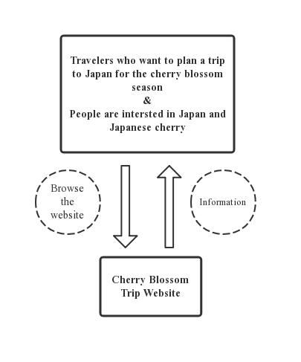

*Figure 2. Scope*

**Structure and Skeleton**

1. **Structure**

* **Site map**

To come up with the general idea of the structure of the whole website, I build the site map to help me generate the frame of my website. (See Figure 3.)

*Figure 3. Site map*

1. **Skeleton**

To make the idea become the real website, figures shown below are the low fidelity wireframe prototypes to build the layout and design of each webpage.

*Figure 4.* *Home*

*Figure 5.* *Homepage*

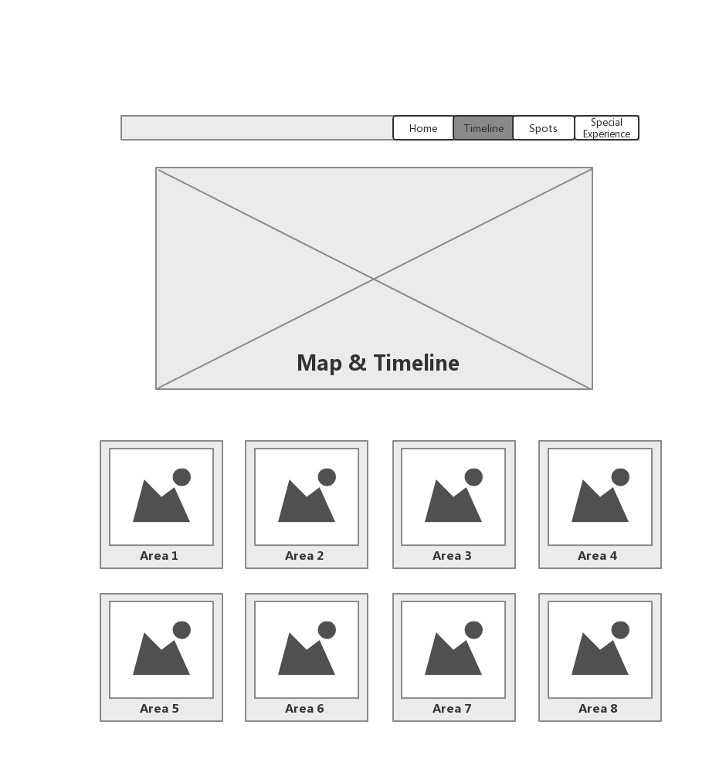

*Figure 6.* *Timeline*

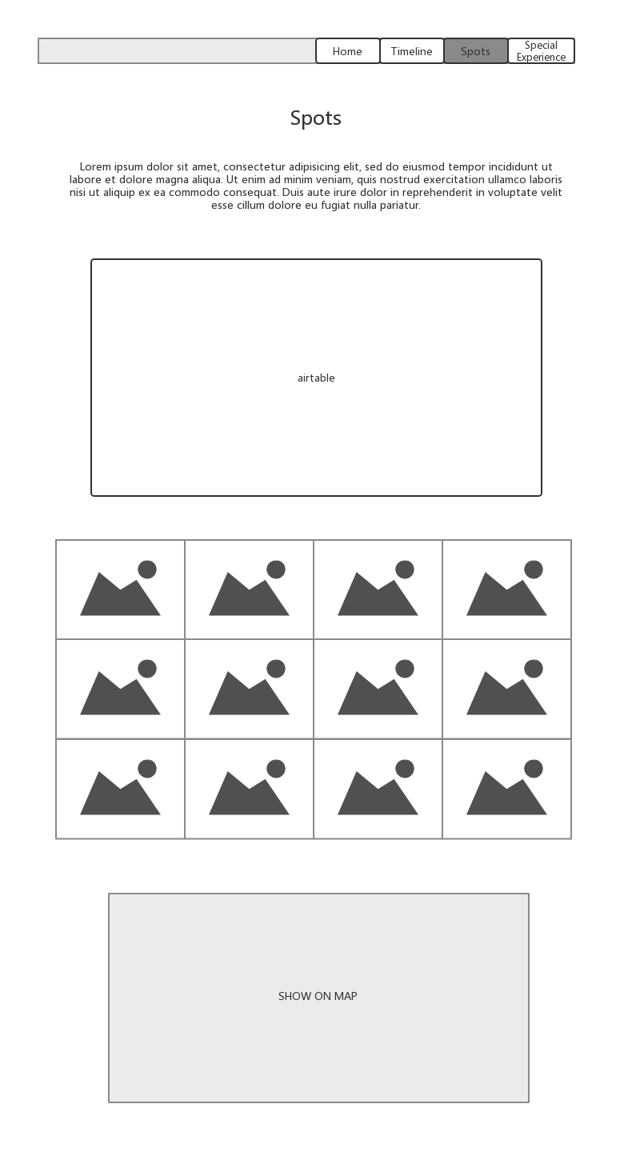

*Figure 7.* *Spots*

*Figure 8.* *Special Experience*

1. **Qualitative Usability Test**

After completing the wireframes, it’s important to know does the website make sense to the users and would it work fluently and well. In order to test whether my layout and design are efficient or not. I invite five mainland friends all have aboard traveling experience and can understand English to do the usability test.

For three of the target users, I made a video call to them and ask them to let me see their faces so I can observe their reaction while answering my questions. And the other two of five users, I did the test with them face to face. Before starting the test, I will tell the users what I am doing is to let them browse the website and they need to answer my questions about what they saw. And I told them they could say anything they want to about this website and there is no need to be hesitate because they are my friends. Also, I explained that there are six pages and eight questions in total in advance.

Then I will let the users browse the website and ask them questions during different steps. Below is the table about the steps, questions and the answer from those 5 testers.

(See Figure 9.)

|  |  |  |  |  |  |  |
| --- | --- | --- | --- | --- | --- | --- |
| **Step** | **Question** | **User 1** | **User 2** | **User 3** | **User 4** | **User 5** |
| Home and Homepage | Q1. What is this website about? | Japan travel | Cherry blossom trip | Travel website | Cherry blossom trip | Cherry blossom trip |
| Timeline | * Q2. Does the layout of the “area” seem methodical? | Need clearer label | Yes | A little bit repetitive | Yes | Yes |
| * Q3. If you want to go to Area 1 to find some spots, do you know where to find that? | Yes | Yes | I want to click the “Area” button in timeline page | Yes | You should change “Spot” to “location” |
| Special Experience | Q4. If you are interested in Japanese cherry related food and drink, do you know where to find that information? | Special experience | Yes | Maybe in Special experience | Yes | Yes |
| Q5. Are you interested in this part? Is this fun for you? | Yes | Yes,  the people who like cherry will like this | Yes | Normal | Yes |
| After browsing  All pages | Q6. Does the website make sense to you? | Yes | Yes | Yes | Yes | Yes |
| Q7. Does the connection between each page strong? | Normal | Yes | Yes | You should combine the home and homepage | You should combine the home and homepage |
| Q8. What should be changed to make the website more consistent? | It’s clearer and more efficient to put timeline and spots together | Timeline and spots seem repetitive | In “spots” section, the position of map and area need to be changed | Booking/Airbnb and other recommendations should directly link to their homepages | Combine spots and timeline |

*Figure 9.* *Usability Test*

As shown above (See Figure.9), testers have given different feedbacks on the general design and layout of the website. They have a clear idea of what this website is about, which is the most important one. The instruct taps at the top of the website make sense to them. Generally, the website is clear and easy to understand. However, they also demonstrate some issues about the website. The first one is that the Home and homepage should be combined to make it more efficient. Moreover, the “timeline” and “spots” are supposed to be connected or combined, so it is easier and methodical for users, which means users could simply check the spots' information by clicking the area buttons. There is no need to separate these two parts. All in all, during the prototyping usability test, these are the two main suggestions to help me make the website more fluent and enhance efficiency.

**Surface**

After finishing all the preparing steps, I finally could turn those needs and problems into solutions. Based on the preliminary designed wireframes and the prototyping usability test, I did some changes on the design and want to make it more practical.

1. **Qualitative 5-second test**

At the beginning of creating the website, I have two plans for the home page design.

One is to use the video background, and another one is to use a picture as background. Although both plans are attractive for me, it’s hard for me to make the decision and represent other users’ preference. So, I conduct 5-second tests to a group of friends who like traveling to see which plan is better for them. According to the test, I choose the picture as the homepage background, since most of them state that it is repetitive because I have another video introduction on another page. The homepage is finally designed like this. (See Figure 10.)

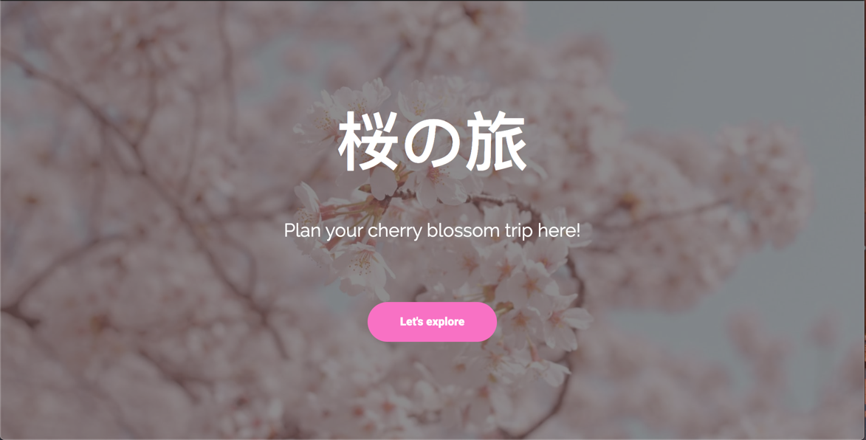

*Figure 10. Designed Homepage*

1. **Surface demonstration**

After a long-time hardworking coding process, I finally get my website done and it could achieve the essential functions and aims. Because it is important to apply on the devices other than PC, I will display some screen shots of the website shown on the phone. (See Figure 11/12/13.)

*Figure 11. Phone version Homepage*

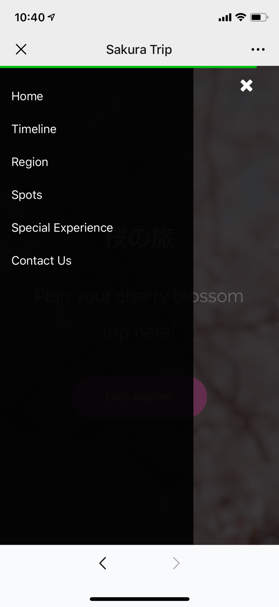

*Figure 12. Phone version dashboard Figure 13. Phone version Region page*

After testing for several time, the website could apply to the phone perfectly and present a comfortable view.

**Quantitative A/B test**

After creating the website, it’s significant to know the practicability for other users. So, I create two versions of the website to test which one is more attractive for the users, and which one will increase the clicking rate.

In this part, I conduct the A/B test with Google Analytics and Optimize. In the new version, I change the button “Let’s Explore” on the homepage to “开始探索”. Moreover, I change the size of the video frame and the font color to see whether this one will be more conspicuous or not so that it has higher possibility users will check the video. (See Figure 14\15.)

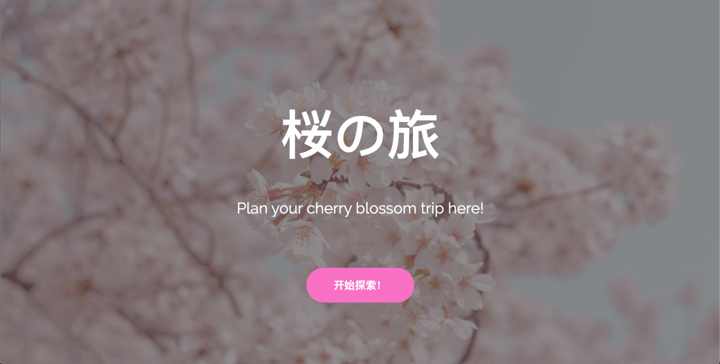

*Figure 14. Home page new version*

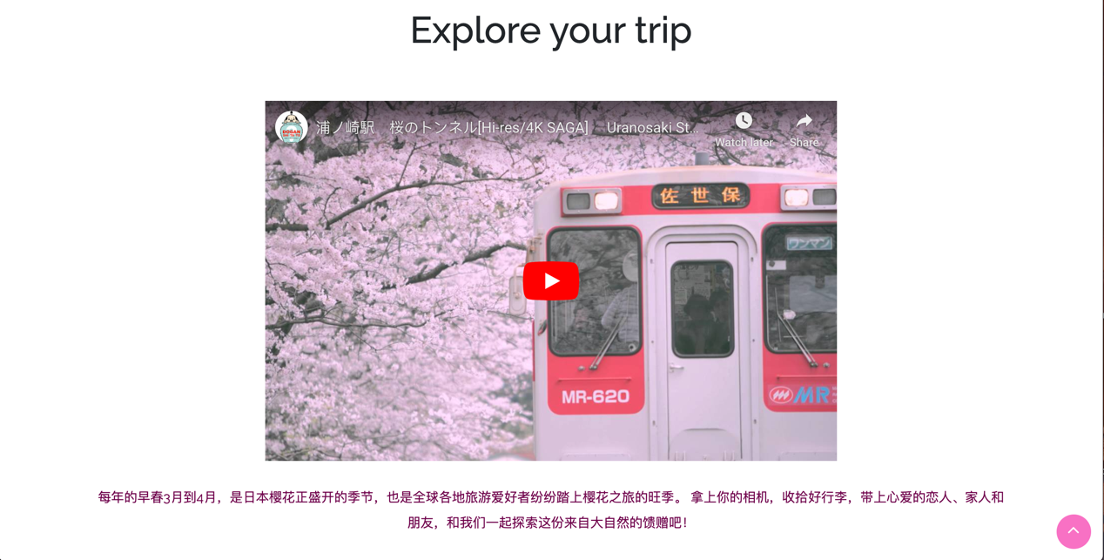

*Figure 15. Video page new version*

After running the experiment for nine days, I get some results and data to decide which one is better or there is no big difference between these two versions. (See Figure 16/17/18.)

*Figure 16. A/B test*

Based on the data, I could find that the original version has a better performance to achieve the goal. One of the goals is to test the click rate of the “Let’s explore” button, which is the button to let the users start to browse the whole website. The rate of the original version is 23.81%, whereas the new version is 12.70%. Also, the original version has a higher target conversion rate than the new version. (See Figure 17.) But the problem is that another goal is to test how many users click the video button, both the original and the new version show that the result is not ideal, there are almost no users click that button. The reason could be the source of the video, since I choose to use a video on YouTube, and some users in China cannot watch the YouTube video, so this may cause the low rate of clicking the video button.

*Figure 17. Comparison of two versions*

*Figure 18. Page view*

**Website Performance**

1. **Traffic Sources**

First of all, the main source is from the referral paths which include WeChat and QQ, the most used social media in China. (See Figure 19.)

*Figure 19. Traffic sources*

1. **Geographic distribution**

In order to get the universal results, I send the website to my friends around the world as much as possible. The result is pretty satisfied since I got various voices all over the world to some extent. Since the Internet speed is quite important when people browsing the website in different areas, this could help me to test whether my website is stable for all users. (See Figure 20.)

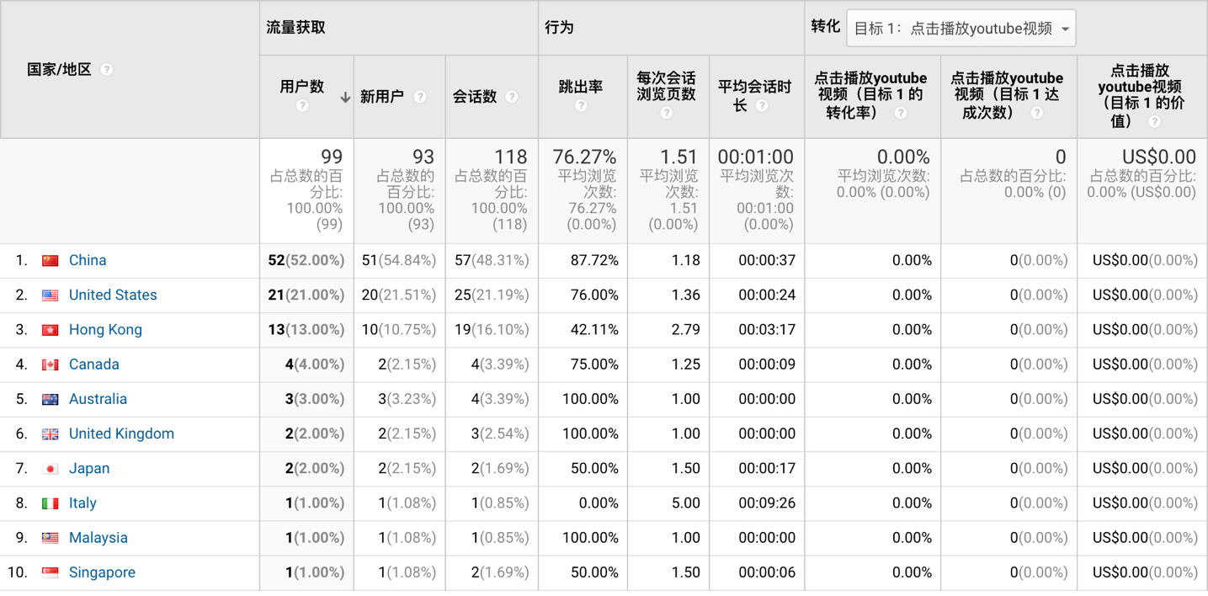

*Figure 20. Geographic distribution*

1. **Other information**

As I mentioned before, it’s important to test whether a website could apply to different devices. According to the Google Analytics result, more than half of the users check my website through mobile devices. (See Figure 21.) And with the technologies developing, more and more people are willing to use their mobile devices for checking the websites or other entertainment activities.

However, the problem is that the average browsing period is too short. There should be more interesting or interactive content to keep users.

*Figure 21. Other information*

**Conclusion**

It was hard to create a website. Starting from thinking the theme to test the website, it was a painful but meaningful process. And the website done is still quite different from the one I image initially. I am satisfied with the general look of the website since I do want to create a pink and lovely website for young girls who like Japanese cherry. However, the content is not that enough for a mature website. I still need to add some special content and make it completed. But this website will be one of the most precious experiences for me in the whole lifetime. Not only a school project but also an interesting journey.